Didsbury High School
Construction Site Newsletter
No.4 – April 2019

Welcome to our newsletter, which aims to keep you up to date with what is happening on our site.

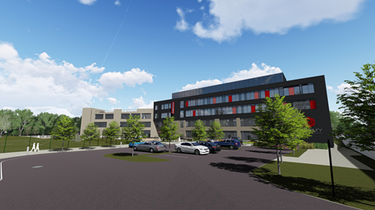
What we are building
A new secondary school, sports hall and associated external facilities to provide much needed additional school places for local residents.

The school, which includes a 6th Form, will open in September 2019. This is a free school, funded directly by the Department for Education, and operated by an approved provider, the Laurus Trust.

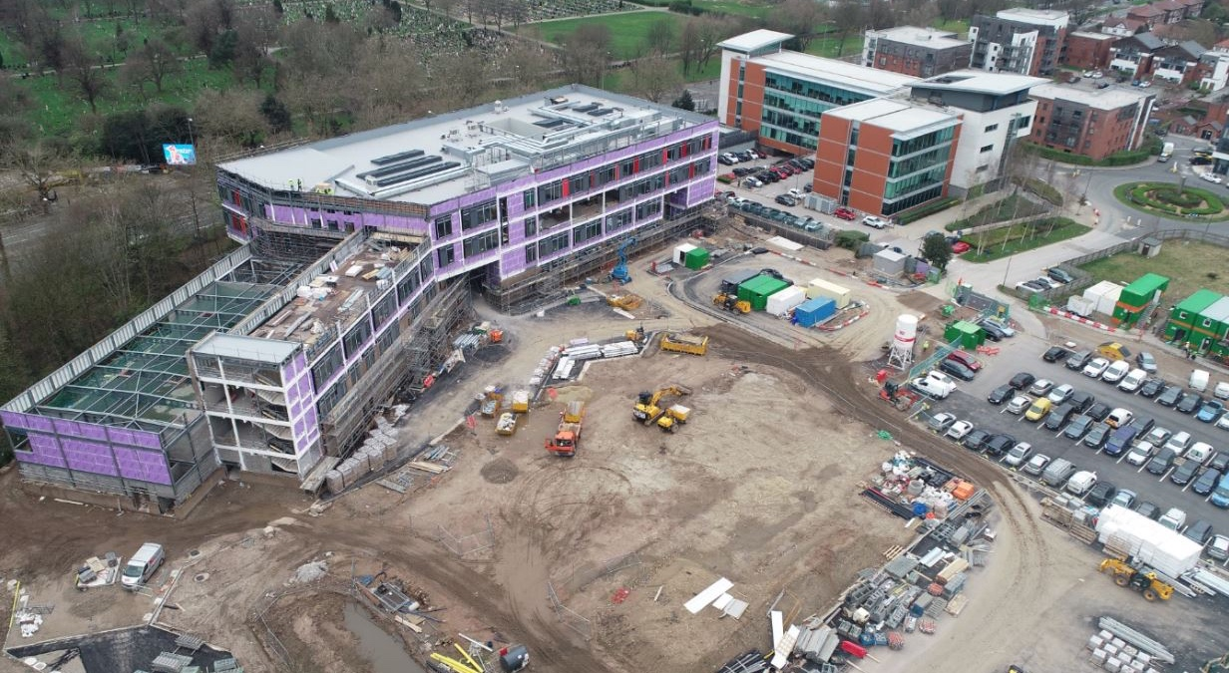
Recent progress
The design of the new school interior is now coming to a close as we see final internal fixed furniture layouts, such as science lab and design technology, being agreed and co-ordinated with all mechanical and electrical services throughout the building.

On site we have seen completion of the steel frame and building envelope, with the secondary brickwork skin progressing well. Internal fit-out works are now in full swing with partition walls nearing completion and joinery, decoration, ceilings and flooring works progressing at pace. The two lifts are also progressing well in line with programme.
Externally, all of the sub-surface drainage and services works are now complete.

The site team
Construction Director: Ged Flanagan
Construction Manager: Ian Greener
Project Manager: James Moore
Senior Site Managers: Simon De Wet/Andy Rainger
Site Managers: Dave Bolderston/Colin Hounslea
Trainee Site Manager: Christian Garner
Senior Project Surveyor: Amir Eltaief
Assistant Project Surveyor: Christian McGeady
Project Planner: Jenny Meah
Design Manager: Lee Parker
Building Services Manager: Steve Yeoman/Graham Tandy

Our partners
Client & Free School Operator: The Laurus Trust
Technical Advisor: Mace
Architect: Pozzoni
Structural Engineer & Env Consultant: Ramboll
Ecology Consultant: TEP

What’s next?
The next quarter will see us bringing the scheme to completion, with the remaining brickwork skin and the internal fit-out, testing and commissioning of the building.

This final period of construction is always the busiest time of any project, so we will see an increase in deliveries and production on site, to ensure we complete the building on programme.

Deliveries to site, and wagons removing spoil from site, continue to utilise The Avenue for access/egress. Parking for all construction related vehicles is accommodated on site, helping to minimise disruption in the surrounding area, and full time security cover, including CCTV monitoring, is in place.

Please help us with safety
Construction sites can be dangerous. At BAM our top priority is the health and safety of everyone who works on our sites, the public and the local community affected by our work. If you need to contact us, please ring us or call the site office but do not enter the site construction zone. Please make any children in your care aware that our building site is not a playground and that they must not enter the site. Thank you for your co-operation.

Considerate Constructors
All BAM sites register with the Considerate Constructors Scheme. This means we are committed to being a good neighbour and to being clean, respectful, safe, environmentally conscious, responsible and accountable. Our site will be independently inspected to make sure we live up to these aims.

At our last Considerate Constructors Inspection on 11 March this year, we scored a fantastic 41/50, demonstrating that we have been working ‘Beyond Compliance’ against the Considerate Constructor’s Scheme scoring criteria.

We try to work in a way that causes as little inconvenience as possible to our neighbours, and apologise for any unavoidable nuisance that may be caused during the work. Please get in touch if you have any concerns and we’ll do what we can to address them.

Environment and community
BAM is committed to helping the environment and community. This includes reducing our carbon emissions, recycling, and wherever possible diverting waste from landfill. The site, design and construction works are overseen by specialist ecology and archaeology consultants.

It is important to BAM to make a positive impact on the local communities in which we work. As much as possible we’ll use local subcontractors and suppliers, and offer employment and training opportunities to local people. We continue to work closely with the Laurus Trust to support other local schools and organisations to give young people from the local area a taste of careers in construction and improve their employability through site visits, educational sessions and work experience. We have had four work experience students on site since the end of last year, providing great experiences and understanding of the processes on site and through the wider design team.

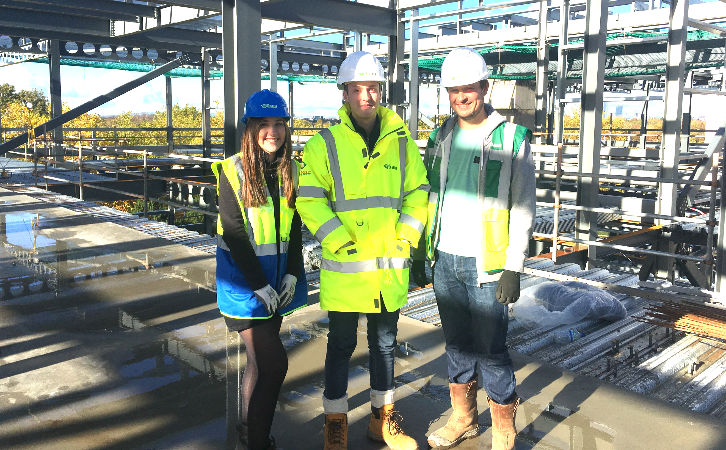

About the Laurus Trust
The Laurus Trust is a multi-academy trust with Cheadle Hulme High School (CHHS), the founder school, at its centre. CHHS is a hugely oversubscribed academy school with a reputation for outstanding teaching and learning and a determination to ensure that every child succeeds. CHHS is the leading secondary school in Stockport and in the top 3% of all schools nationally based on 2017 Progress 8 results. In 2015 and 2011, CHHS was judged Outstanding by Ofsted in every category.

The Trust is opening this school with the full support of Manchester City Council, in order to provide much needed additional secondary school places for children currently in year 6 and below in Didsbury primary schools. The Laurus Trust also operates an Ofsted Outstanding teacher training centre and supports a number of other schools through its Teaching School.
About BAM
BAM Construction is part of BAM Construct UK which is one of the country’s largest construction services organisations with a turnover of more than £900 million. We operate throughout England, Scotland and Wales. Our European parent company is Royal BAM Group which employs over 25,000 people worldwide and has a turnover of €7billion.

The team building this school project is made up of local people living across the North West and our regional office is in Salford. BAM have successfully delivered many school projects across the country over the last 5 years, and recent experiences in the region include the delivery of Kearsley Academy, MediaCity UTC and Crewe UTC. BAM have also recently completed the new Laurus Cheadle Hulme Primary and Secondary School and are currently building a third new school for the Trust at Laurus Ryecroft.

